Task 15:
Add 2 new hard disk on pc1 (VM)
Configure RAID

RAID 0
1. Added two new hard disk to pc1.
2. Created partition in /dev/sdb1 /dev/sdc1 with 8GB size and partition id is fd.
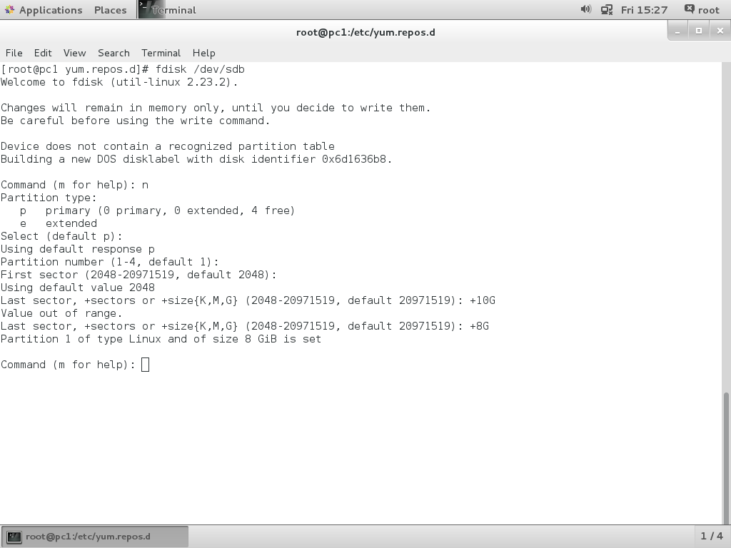
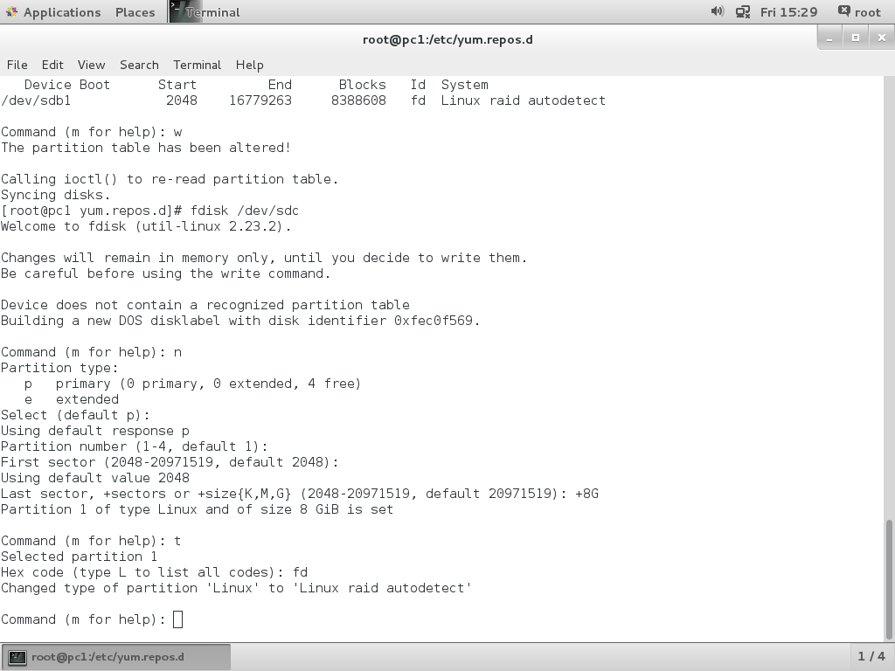

3.Create raid0 using below command
mdadm --create /dev/md5 --level=stripe --raid-device=2 /dev/sd[b-c]1

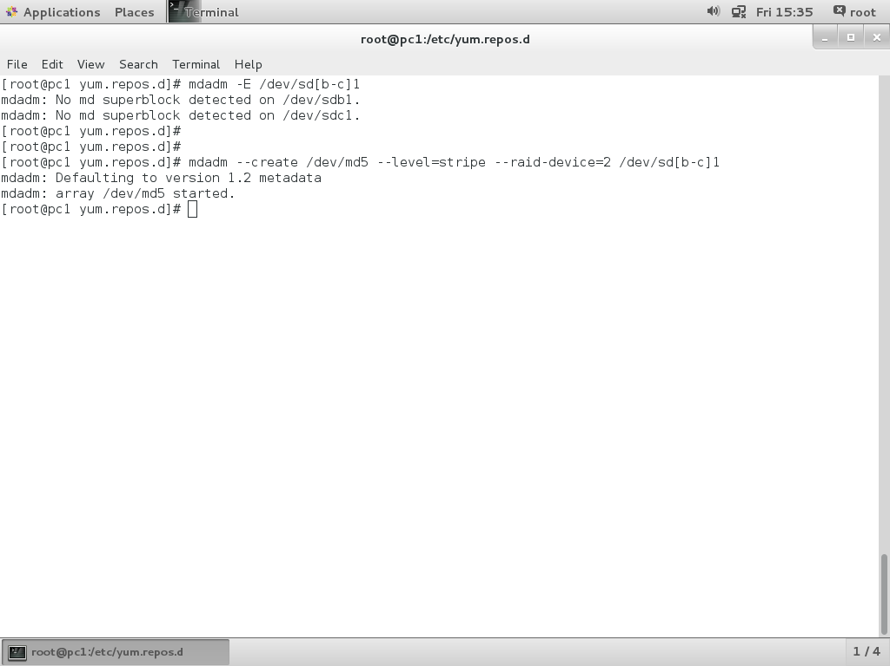
4. Check raid0 as below
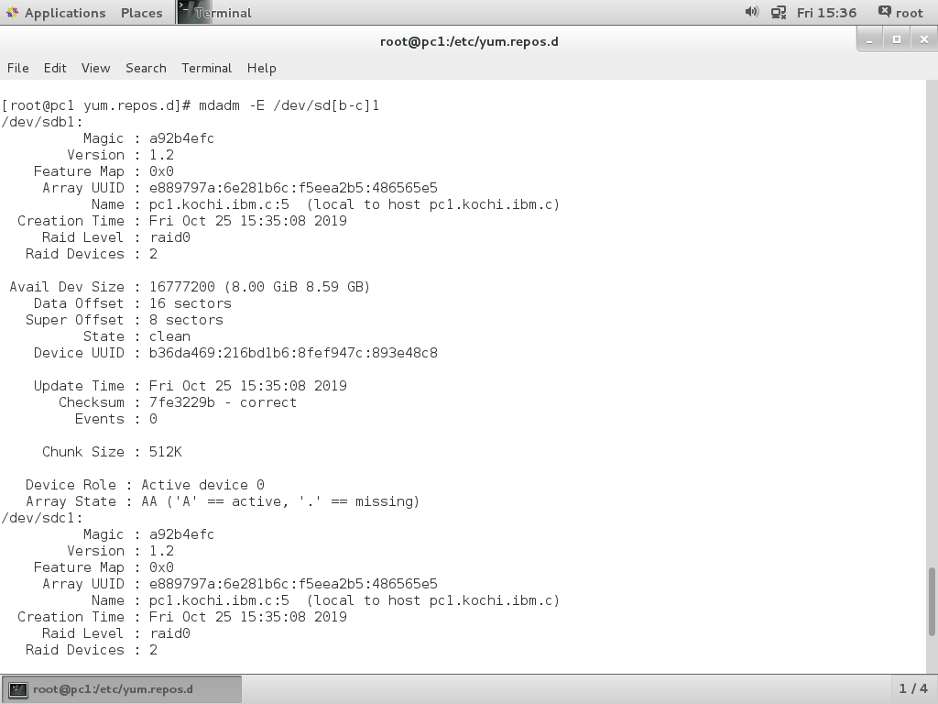
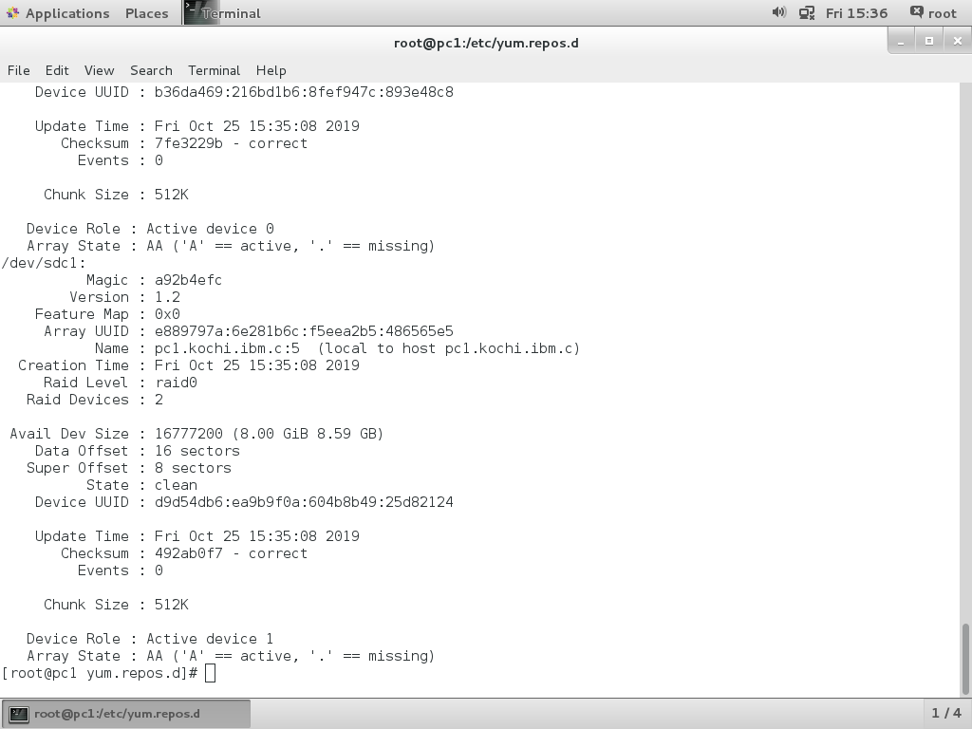
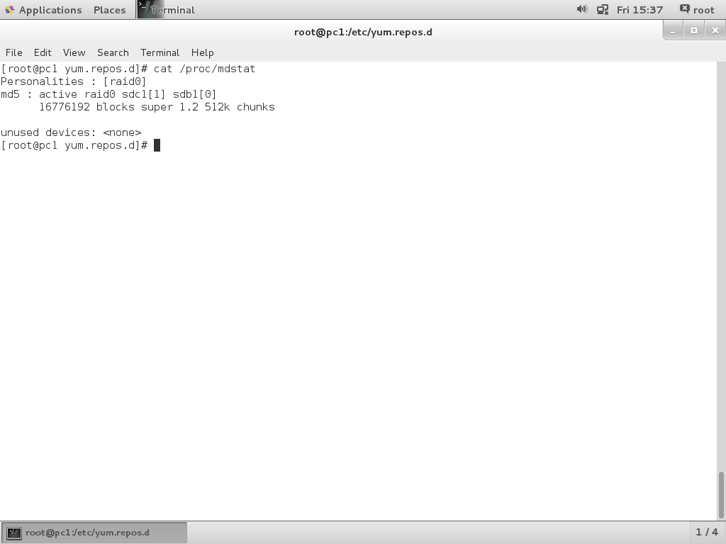
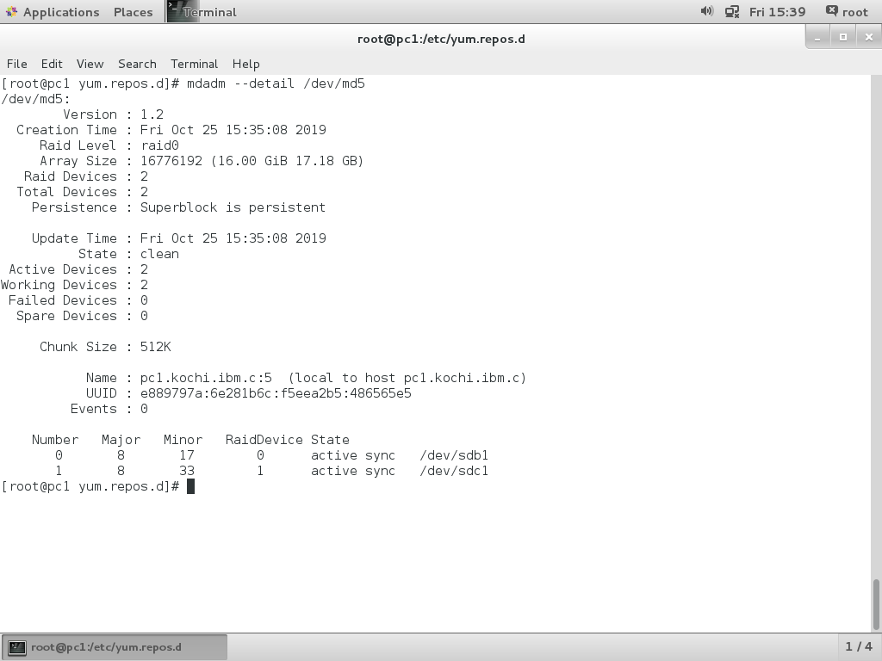

5. Formated /dev/md5 as xfs file system.
Mounted /dev/md5 to /mnt/raid0 using UUID.
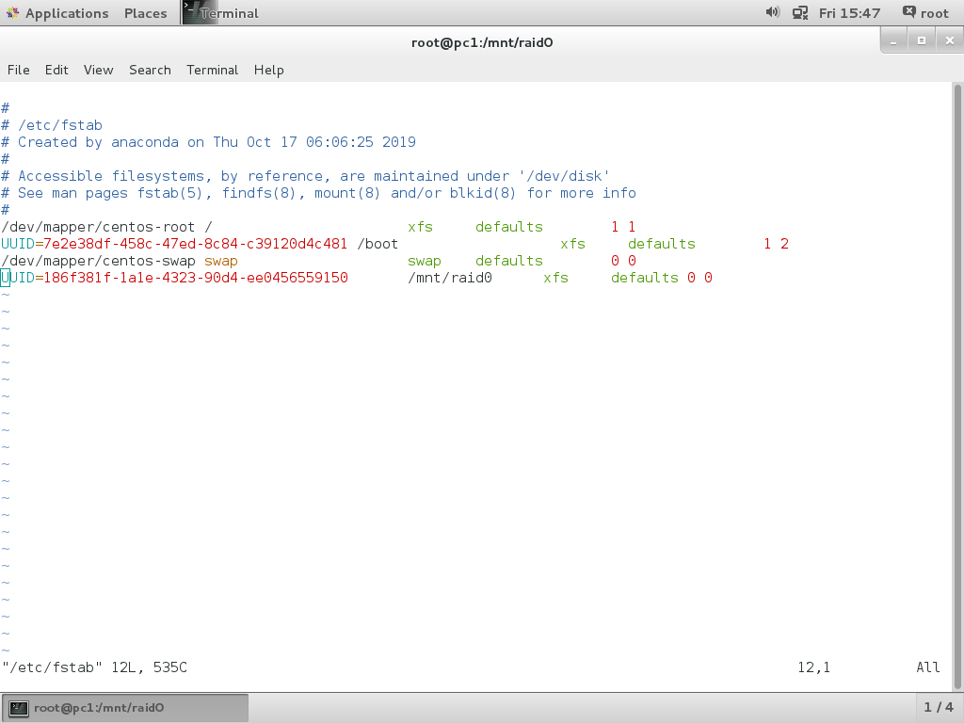

RAID 1
1. Added two new hard disk to pc1.
2. Created partition in /dev/sdb1 /dev/sdc1 with 5GB size and partition id is fd.
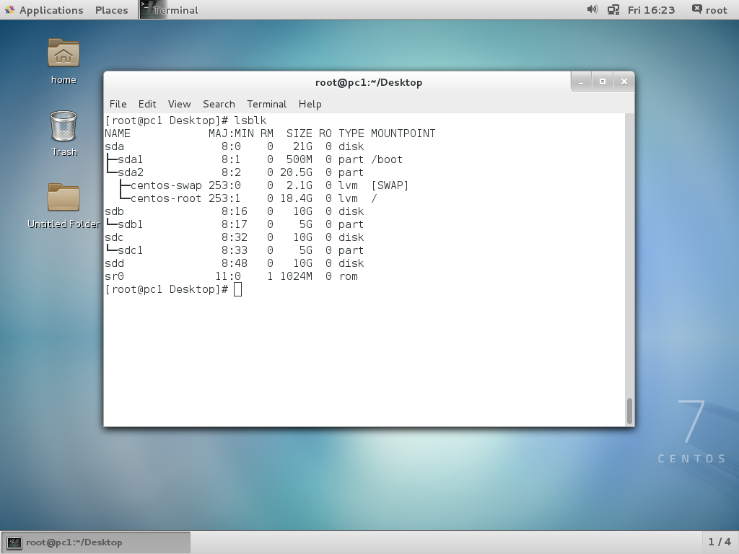
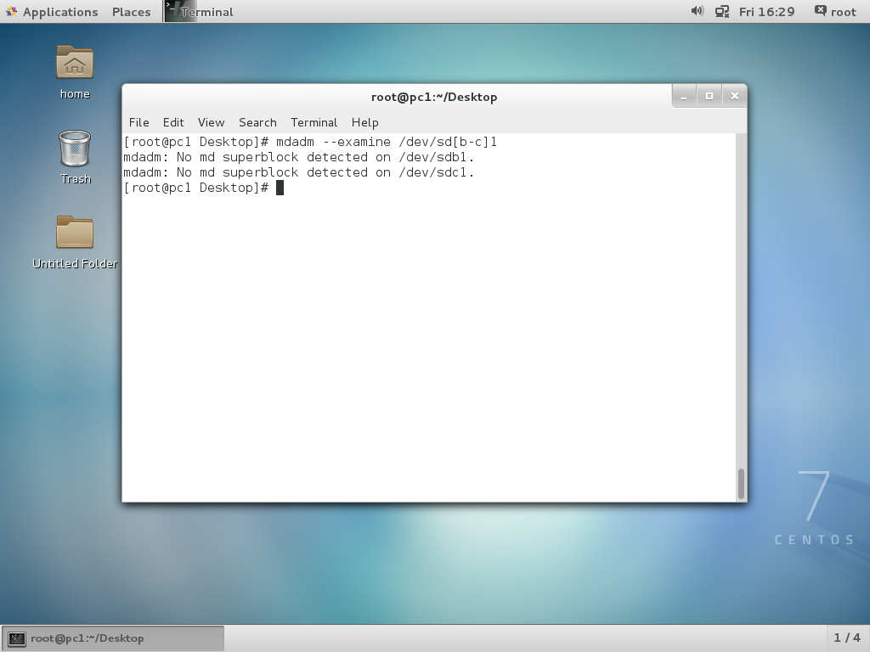

3.Create raid0 using below command
mdadm --create /dev/md1 --level=mirror --raid-device=2 /dev/sd[b-c]1
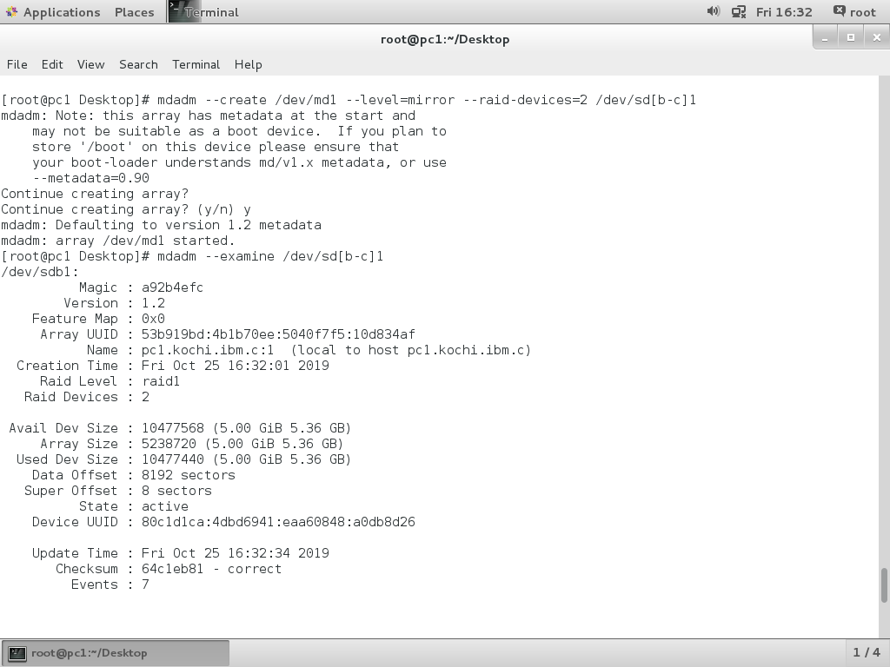
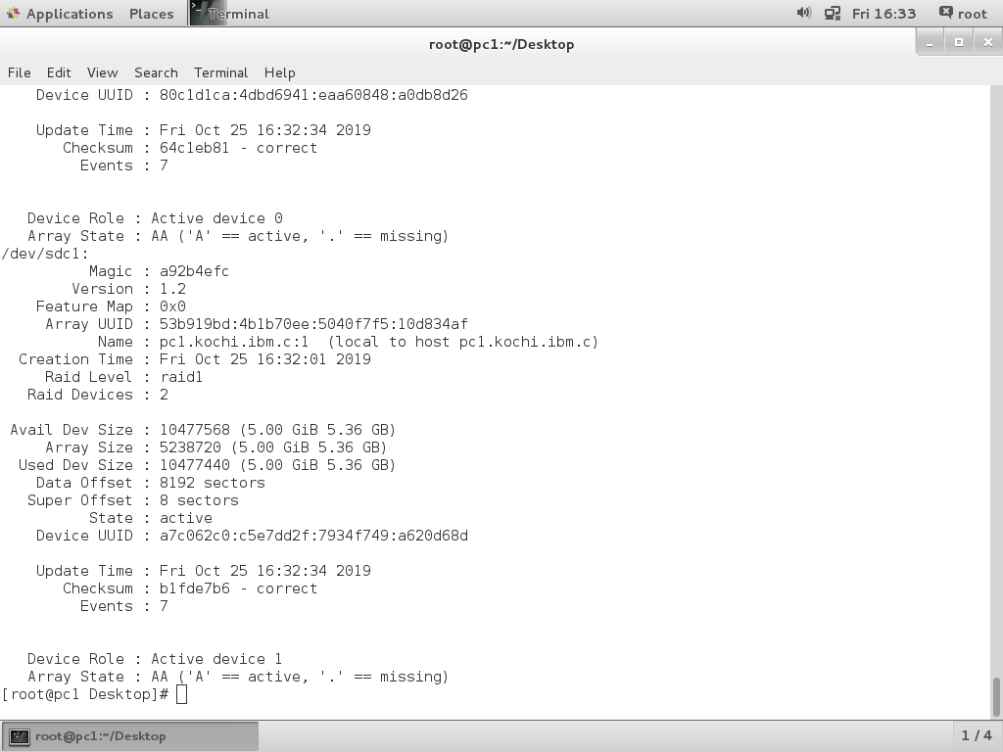

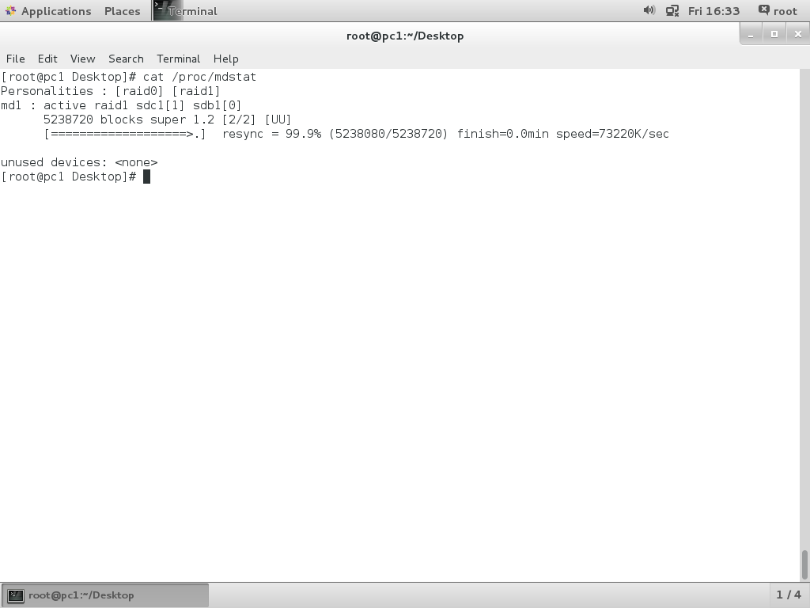
4.Mount /dev/md1 to /mnt/raid1
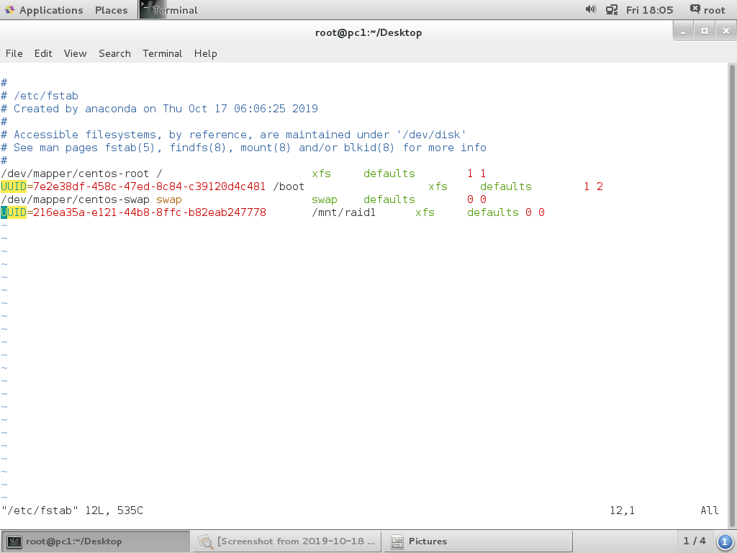
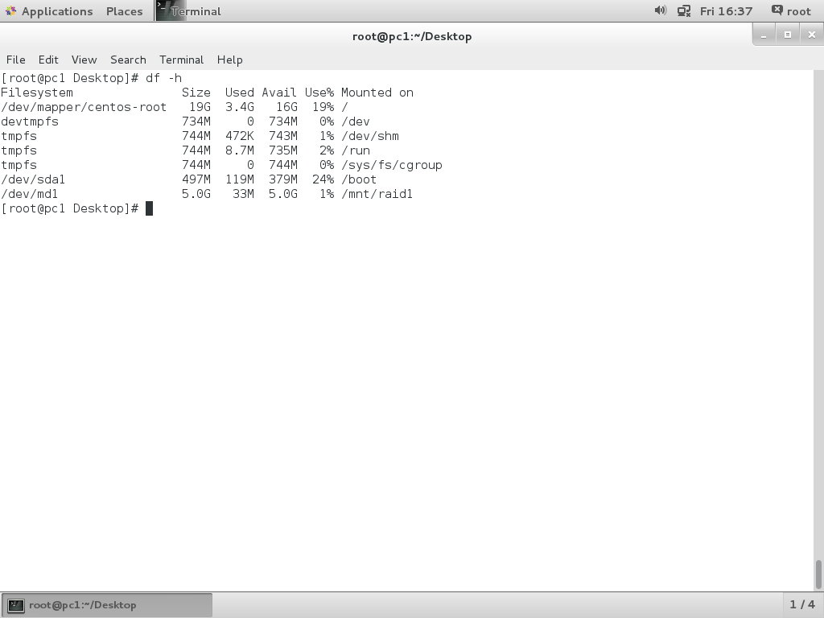
5. Create one file file1.txt in /mnt/raid1
6. Make fail one hard disk /dev/sdc1
mdadm –manage –fail /dev/md1 /dev/sdc1

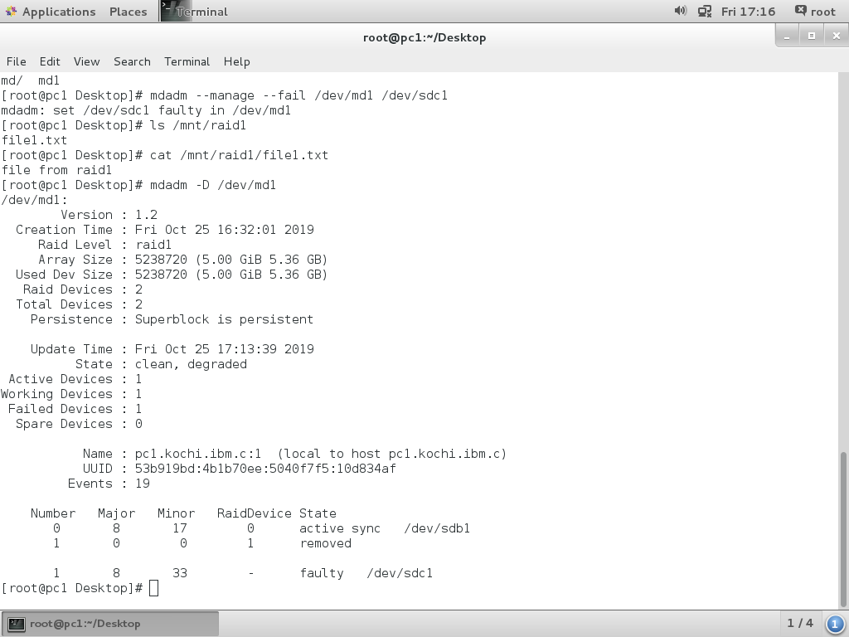

7. After fail one disk /dev/sdc1 able to access file1.txt in /mnt/raid1
